Project Documentation

Project idea

As I have done C# before I have decided to continue one of my old projects so as to minimise the amount of workload I have at the moment. My old project is a snakes and ladders program that has a menu form that pops up with an option to choose how many players and a begin button and a main form where the game is played out.

Changes I will make

The way I will use this project to fulfil the assessment criteria:

To fulfil the saving to file part of the criteria:

I am going to add an optional save at the end of the game which will save a text file with the winner of the game and the final positions of all the players in that game.

To fulfil the loading from file part of the criteria:

I am going to allow the players to choose different images from the file explorer to represent them. They will be able to choose from png’s and jpeg’s that they have in their files.

Design

Settings Screen:

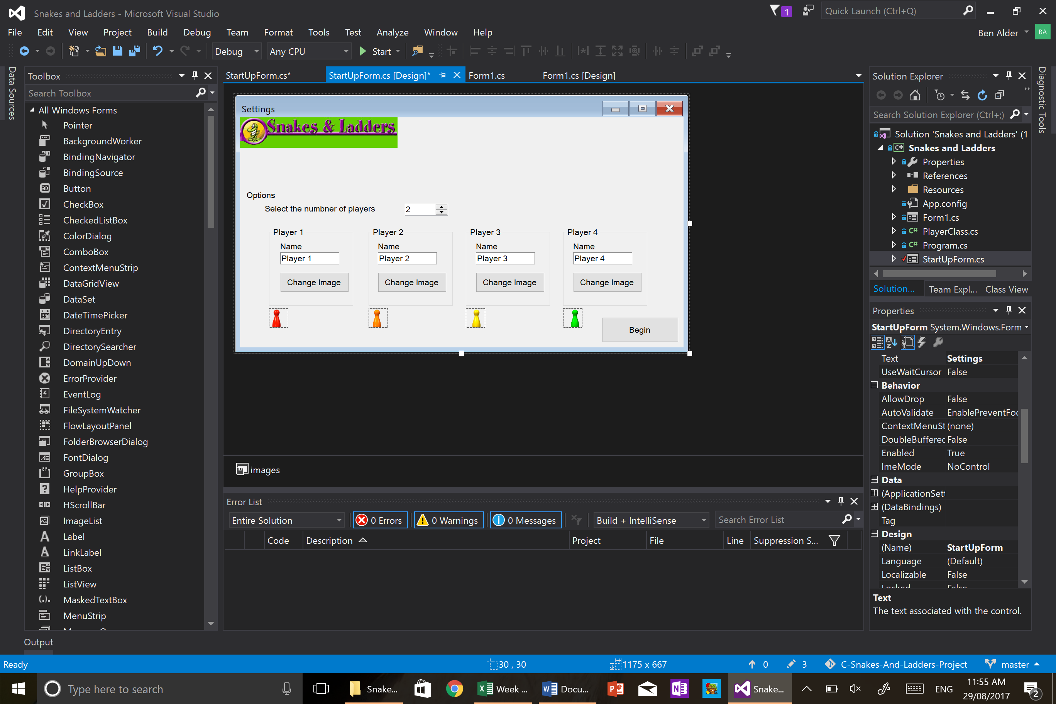

This is the screen that will open up when the users start the snakes and ladders project. When it starts players 3 and 4’s options will be disabled, this will change when the user changed the number of players numeric up/down.

Main Form:

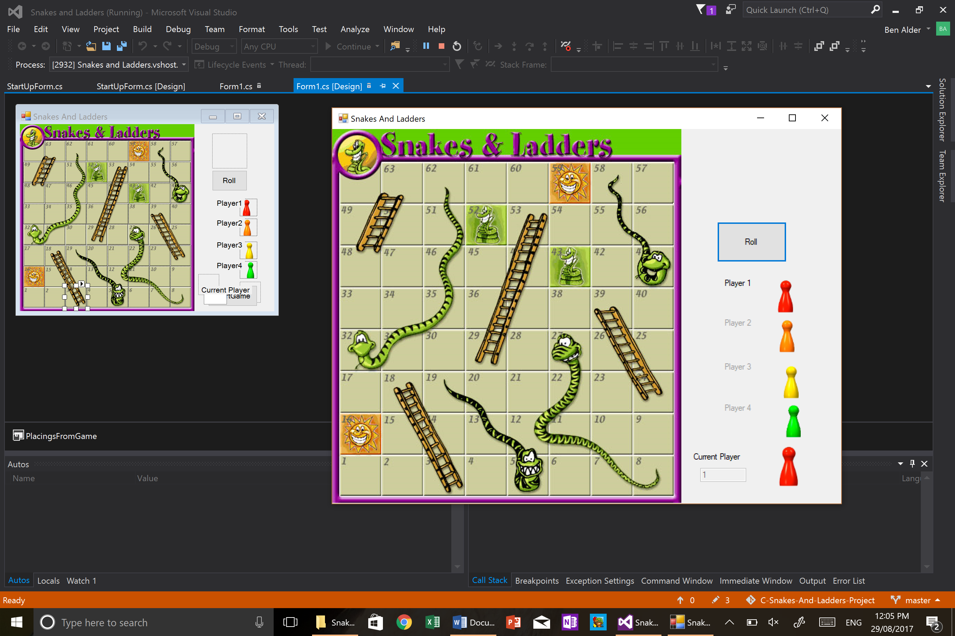

This is the game view that starts up after the user clicks the begin button. This view shows the game before any of the players have a position on the board.

State flow diagram

Begin button clicked

Close

Run Game

Options Screen

Open Program

Post Mortem

During the project I had to implement saving of files and loading from files. These concepts and the implementation of them was not difficult to complete. The majority of my time during this subject was spent trying to decide what tool I was going to make, until I discussed what I should work on with my teacher. And then from there it was fairly simple to complete the project.